iGaming Project: Database Schema & Logic Documentation

1. System Architecture Overview
The architecture is designed for a high-throughput, low-latency iGaming platform (likely a Casino/Slot system). The data is split into two distinct logical domains to separate "hot" gameplay data from "cold" reference data.
- RCasinoKS (Gameplay Engine): Handles high-frequency write operations. This keyspace contains active game sessions, spins, bets, and round history. It is optimized for speed and uses short Time-To-Live (TTL) on some tables to auto-expire old data.
- RCasinoSCKS (Platform Core): Handles "warm/cold" data such as player wallets, banking configurations, promotions, and immutable history. This data is read-heavy and generally persistent.

2. The Logic Flow: "Life of a Spin"
To understand the relations, it helps to follow the data during a single user interaction (a Spin).

Phase A: Session Start
- User Login: The system verifies the user against rcasinoscks.accountcf (Player Profile) and loads the Casino/Tenant settings from rcasinoscks.bankinfocf.
- Session Creation: A new session is inserted into rcasinoks.gamesessioncf.
  - Purpose: This is the "Master" record for the user's current gameplay window.
  - Key Data: gsid (Session ID), accid (Player ID), bid (Bank ID), balance.

Phase B: The Gameplay (The Spin)
When the player presses "Spin":
- Record Round: A new row is written to rcasinoks.roundgamesessioncf.
  - Relation: Links the new round_id to the active gsid.
- Place Bet: The wager amount is logged in rcasinoks.betcf.
- Save Game State: The visual result (e.g., the position of the reels) is saved in rcasinoks.wopcf.
  - Critical Field: jcn (JSON Content) and scn (Serialized Content). These "Blobs" store the exact screen state to ensure the round can be replayed for audit purposes.
- Update Stats: The system increments the bets, income, and payout counters in the main gamesessioncf table.

Phase C: The Aftermath
- History Archive: The round is written to rcasinoks.battlegroundhistory.
  - Optimization: This table is clustered by datetime, allowing the "My History" feature to quickly show the last 50 rounds without scanning the entire database.
- Wallet Update: If money was won/lost, a transaction is written to rcasinoscks.paymenttransactioncf2.

3. Deep Dive: Key Table Responsibilities

A. Gameplay Keyspace (RCasinoKS)
Table Name | Purpose | Key Relationships
gamesessioncf | The Source of Truth. Tracks the active session state, total bets, and winnings. | gsid (PK), accid, bid
roundgamesessioncf | Maps specific Rounds to a Session. | game_sid → gamesessioncf.gsid
wopcf | Win/Operation. Stores the raw result (JSON/Blob) of the game round. | roundid, gamesessid
gamesessioncf_ag | Materialized View. Allows finding sessions by Account ID. | accid → gamesessioncf.accid
battlegroundhistory | Player History. Optimized for displaying "Last X Rounds" to the user. | accountid, datetime

B. Platform Keyspace (RCasinoSCKS)
Table Name | Purpose | Key Relationships
accountcf | Core Player Profile (Name, Status, Currency). | key = accid
bankinfocf | Tenant Config. Settings for the specific Casino Operator (Bank). | key = bid
promocampaigncf | Metadata for active marketing campaigns/tournaments. | campid
depositscf | Logs deposits made during an active session. | sessid

4. Key Design Patterns & Logic
Since Cassandra does not support SQL JOINs, the application uses specific design patterns to handle relationships.

Pattern 1: Materialized Views for Search
You cannot query gamesessioncf by "Player Name" because it is keyed by gsid.
- Solution: The schema includes gamesessioncf_ag (Active Games by Account) and gamesessioncf_bag_idx (Active Games by Bank).
- Logic: To find a player's session, the app first queries gamesessioncf_ag with the accid to get the gsid, then queries gamesessioncf with that gsid to get the details.

Pattern 2: Client-Side "Joins"
To generate a report (e.g., "Total Loss for Player X today"):
- Query 1: Select all gsids from gamesessioncf_ag where accid = X and day = TODAY.
- Query 2: Loop through those gsids and select income and payout from gamesessioncf.
- Calculation: Total Loss = Sum(income) - Sum(payout) (Performed in C#/Java/Python, not the DB).

Pattern 3: The "Blob" Audit Trail
Tables like wopcf and battlegroundhistory contain scn (Blob) and jcn (Text) columns.
- Purpose: These store the serialized game state. If a user complains about a glitch, the support tool retrieves this Blob and "replays" the round exactly as it happened, proving the result was fair.
https://dbdiagram.io/d/69677574d6e030a024032d37

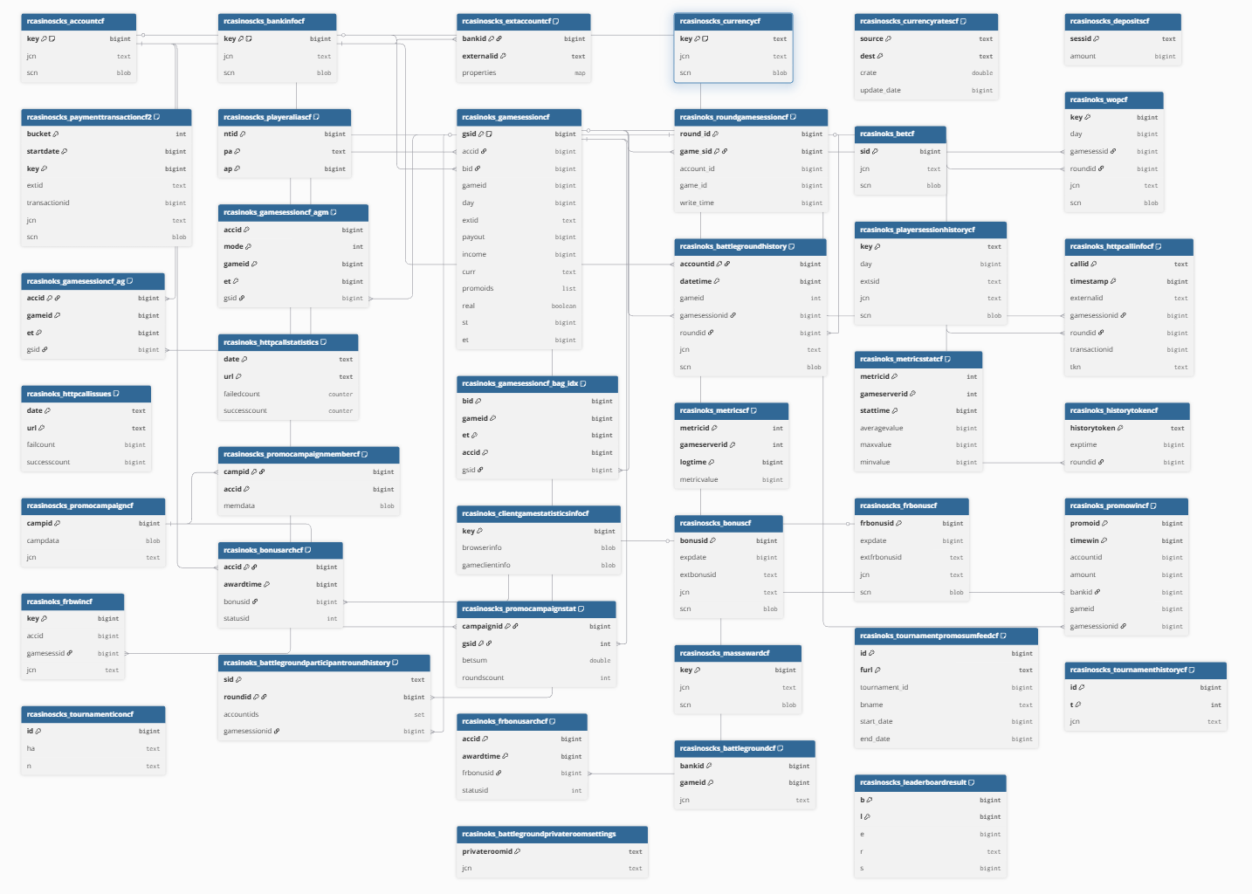
Project RCasino_Full {
database_type: 'Cassandra'
Note: 'Full Schema: RCasinoKS (Gameplay) & RCasinoSCKS (Platform)'
}

// =======================================================
// GROUP: CORE PLATFORM (Accounts, Banks, Wallet)
// =======================================================
TableGroup Platform_Core {
rcasinoscks_accountcf
rcasinoscks_bankinfocf
rcasinoscks_extaccountcf
rcasinoscks_currencycf
rcasinoscks_currencyratescf
rcasinoscks_depositscf
rcasinoscks_paymenttransactioncf2
rcasinoscks_playeraliascf
}

Table rcasinoscks_accountcf {
key bigint [pk, note: 'Player Account ID']
jcn text
scn blob
}

Table rcasinoscks_bankinfocf {
key bigint [pk, note: 'Bank/Tenant ID']
jcn text
scn blob
}

Table rcasinoscks_extaccountcf {
bankid bigint [pk]
externalid text [pk]
properties map
}

Table rcasinoscks_currencycf {
key text [pk, note: 'Currency Code']
jcn text
scn blob
}

Table rcasinoscks_currencyratescf {
source text [pk]
dest text [pk]
crate double
update_date bigint
}

Table rcasinoscks_depositscf {
sessid text [pk]
amount bigint
}

Table rcasinoscks_paymenttransactioncf2 {
bucket int [pk]
startdate bigint [pk]
key bigint [pk]
extid text
transactionid bigint
jcn text
scn blob
}

Table rcasinoscks_playeraliascf {
ntid bigint [pk]
pa text [pk]
ap bigint [pk]
}

// =======================================================
// GROUP: GAME SESSIONS (The "Heart" of the system)
// =======================================================
TableGroup Game_Sessions {
rcasinoks_gamesessioncf
rcasinoks_roundgamesessioncf
rcasinoks_betcf
rcasinoks_wopcf
rcasinoks_gamesessioncf_ag
rcasinoks_gamesessioncf_agm
rcasinoks_gamesessioncf_bag_idx
}

Table rcasinoks_gamesessioncf {
gsid bigint [pk, note: 'Game Session ID']
accid bigint
bid bigint
gameid bigint
day bigint
extid text
payout bigint
income bigint
curr text
promoids list
real boolean
st bigint
et bigint
}

Table rcasinoks_roundgamesessioncf {
round_id bigint [pk]
game_sid bigint [pk]
account_id bigint
game_id bigint
write_time bigint
}

Table rcasinoks_betcf {
sid bigint [pk]
jcn text
scn blob
}

Table rcasinoks_wopcf {
key bigint [pk]
day bigint
gamesessid bigint
roundid bigint
jcn text
scn blob
}

// Materialized Views (Denormalized Session Data)
Table rcasinoks_gamesessioncf_ag {
accid bigint [pk]
gameid bigint [pk]
et bigint [pk]
gsid bigint
}

Table rcasinoks_gamesessioncf_agm {
accid bigint [pk]
mode int [pk]
gameid bigint [pk]
et bigint [pk]
gsid bigint
}

Table rcasinoks_gamesessioncf_bag_idx {
bid bigint [pk]
gameid bigint [pk]
et bigint [pk]
accid bigint [pk]
gsid bigint
}

// =======================================================
// GROUP: HISTORY & LOGS
// =======================================================
TableGroup History_Logs {
rcasinoks_battlegroundhistory
rcasinoks_playersessionhistorycf
rcasinoks_httpcallinfocf
rcasinoks_httpcallissues
rcasinoks_httpcallstatistics
rcasinoks_clientgamestatisticsinfocf
rcasinoks_metricscf
rcasinoks_metricsstatcf
rcasinoks_historytokencf
}

Table rcasinoks_battlegroundhistory {
accountid bigint [pk]
datetime bigint [pk]
gameid int
gamesessionid bigint
roundid bigint
jcn text
scn blob
}

Table rcasinoks_playersessionhistorycf {
key text [pk]
day bigint
extsid text
jcn text
scn blob
}

Table rcasinoks_httpcallinfocf {
callid text [pk]
timestamp bigint [pk]
externalid text
gamesessionid bigint
roundid bigint
transactionid bigint
tkn text
}

Table rcasinoks_httpcallissues {
date text [pk]
url text [pk]
failcount bigint
successcount bigint
}

Table rcasinoks_httpcallstatistics {
date text [pk]
url text [pk]
failedcount counter
successcount counter
}

Table rcasinoks_clientgamestatisticsinfocf {
key bigint [pk]
browserinfo blob
gameclientinfo blob
}

Table rcasinoks_metricscf {
metricid int [pk]
gameserverid int [pk]
logtime bigint [pk]
metricvalue bigint
}

Table rcasinoks_metricsstatcf {
metricid int [pk]
gameserverid int [pk]
stattime bigint [pk]
averagevalue bigint
maxvalue bigint
minvalue bigint
}

Table rcasinoks_historytokencf {
historytoken text [pk]
exptime bigint
roundid bigint
}

// =======================================================
// GROUP: PROMOTIONS & BONUSES
// =======================================================
TableGroup Promotions {
rcasinoscks_promocampaigncf
rcasinoscks_promocampaignmembercf
rcasinoscks_promocampaignstat
rcasinoscks_bonuscf
rcasinoscks_frbonuscf
rcasinoks_promowincf
rcasinoks_frbwincf
rcasinoks_bonusarchcf
rcasinoks_frbonusarchcf
rcasinoscks_massawardcf
}

Table rcasinoscks_promocampaigncf {
campid bigint [pk]
campdata blob
jcn text
}

Table rcasinoscks_promocampaignmembercf {
campid bigint [pk]
accid bigint [pk]
memdata blob
}

Table rcasinoscks_promocampaignstat {
campaignid bigint [pk]
gsid int [pk]
betsum double
roundscount int
}

Table rcasinoscks_bonuscf {
bonusid bigint [pk]
expdate bigint
extbonusid text
jcn text
scn blob
}

Table rcasinoscks_frbonuscf {
frbonusid bigint [pk]
expdate bigint
extfrbonusid text
jcn text
scn blob
}

Table rcasinoks_promowincf {
promoid bigint [pk]
timewin bigint [pk]
accountid bigint
amount bigint
bankid bigint
gameid bigint
gamesessionid bigint
}

Table rcasinoks_frbwincf {
key bigint [pk]
accid bigint
gamesessid bigint
jcn text
}

Table rcasinoks_bonusarchcf {
accid bigint [pk]
awardtime bigint [pk]
bonusid bigint
statusid int
}

Table rcasinoks_frbonusarchcf {
accid bigint [pk]
awardtime bigint [pk]
frbonusid bigint
statusid int
}

Table rcasinoscks_massawardcf {
key bigint [pk]
jcn text
scn blob
}

// =======================================================
// GROUP: TOURNAMENTS & BATTLEGROUNDS
// =======================================================
TableGroup Tournaments {
rcasinoks_tournamentpromosumfeedcf
rcasinoscks_tournamenthistorycf
rcasinoscks_tournamenticoncf
rcasinoks_battlegroundparticipantroundhistory
rcasinoks_battlegroundprivateroomsettings
rcasinoscks_battlegroundcf
rcasinoscks_leaderboardresult
}

Table rcasinoks_tournamentpromosumfeedcf {
id bigint [pk]
furl text [pk]
tournament_id bigint
bname text
start_date bigint
end_date bigint
}

Table rcasinoscks_tournamenthistorycf {
id bigint [pk]
t int [pk]
jcn text
}

Table rcasinoscks_tournamenticoncf {
id bigint [pk]
ha text
n text
}

Table rcasinoks_battlegroundparticipantroundhistory {
sid text [pk]
roundid bigint [pk]
accountids set
gamesessionid bigint
}

Table rcasinoks_battlegroundprivateroomsettings {
privateroomid text [pk]
jcn text
}

Table rcasinoscks_battlegroundcf {
bankid bigint [pk]
gameid bigint [pk]
jcn text
}

Table rcasinoscks_leaderboardresult {
b bigint [pk]
l bigint [pk]
e bigint
r text
s bigint
}

// =======================================================
// RELATIONSHIPS (Inferred from schema logic)
// =======================================================

// --- ACCOUNT & BANK CONNECTIONS ---
// Linking sessions to the player account
Ref: rcasinoscks_accountcf.key < rcasinoks_gamesessioncf.accid
Ref: rcasinoscks_accountcf.key < rcasinoks_gamesessioncf_ag.accid
Ref: rcasinoscks_accountcf.key < rcasinoks_battlegroundhistory.accountid
Ref: rcasinoscks_accountcf.key < rcasinoks_bonusarchcf.accid

// Linking sessions to the bank (tenant)
Ref: rcasinoscks_bankinfocf.key < rcasinoks_gamesessioncf.bid
Ref: rcasinoscks_bankinfocf.key < rcasinoscks_extaccountcf.bankid
Ref: rcasinoscks_bankinfocf.key < rcasinoks_promowincf.bankid

// --- GAME SESSION CONNECTIONS ---
// The Game Session ID (gsid) is the central key
Ref: rcasinoks_gamesessioncf.gsid < rcasinoks_roundgamesessioncf.game_sid
Ref: rcasinoks_gamesessioncf.gsid < rcasinoks_wopcf.gamesessid
Ref: rcasinoks_gamesessioncf.gsid < rcasinoks_gamesessioncf_ag.gsid
Ref: rcasinoks_gamesessioncf.gsid < rcasinoks_gamesessioncf_agm.gsid
Ref: rcasinoks_gamesessioncf.gsid < rcasinoks_gamesessioncf_bag_idx.gsid
Ref: rcasinoks_gamesessioncf.gsid < rcasinoks_battlegroundhistory.gamesessionid
Ref: rcasinoks_gamesessioncf.gsid < rcasinoks_httpcallinfocf.gamesessionid
Ref: rcasinoks_gamesessioncf.gsid < rcasinoks_promowincf.gamesessionid
Ref: rcasinoks_gamesessioncf.gsid < rcasinoks_frbwincf.gamesessid
Ref: rcasinoks_gamesessioncf.gsid < rcasinoks_battlegroundparticipantroundhistory.gamesessionid
Ref: rcasinoks_gamesessioncf.gsid < rcasinoscks_promocampaignstat.gsid

// --- ROUND CONNECTIONS ---
Ref: rcasinoks_roundgamesessioncf.round_id < rcasinoks_wopcf.roundid
Ref: rcasinoks_roundgamesessioncf.round_id < rcasinoks_battlegroundhistory.roundid
Ref: rcasinoks_roundgamesessioncf.round_id < rcasinoks_httpcallinfocf.roundid
Ref: rcasinoks_roundgamesessioncf.round_id < rcasinoks_historytokencf.roundid
Ref: rcasinoks_roundgamesessioncf.round_id < rcasinoks_battlegroundparticipantroundhistory.roundid

// --- PROMO & BONUS CONNECTIONS ---
Ref: rcasinoscks_promocampaigncf.campid < rcasinoscks_promocampaignmembercf.campid
Ref: rcasinoscks_promocampaigncf.campid < rcasinoscks_promocampaignstat.campaignid
Ref: rcasinoscks_bonuscf.bonusid < rcasinoks_bonusarchcf.bonusid
Ref: rcasinoscks_frbonuscf.frbonusid < rcasinoks_frbonusarchcf.frbonusid

